Fractions

Kelly Blair
(Central School, kelly_blair@bemidji.k12.mn.us)

Laci Podmore
(Central School, laci_podmore@bemidji.k12.mn.us)

Grade 5

Executive Summary

This is a fifth grade math unit on fractions. Specifically, it addresses how to add fractions with unlike denominators, subtract fractions with unlike denominators, and put fractions into simplest form through prime factorization. The focus is on Minnesota fifth grade math standards 5.1.2.4 (recognize and generate equivalent decimals, fractions, mixed numbers and improper fractions in various contexts), 5.1.3.1 (add and subtract decimals and fractions, using efficient and generalizable procedures, including standard algorithms), and 5.1.3.2 (model addition and subtraction of fractions and decimals using a variety of representation).

This unit is designed for Tier 2 and Tier 3 students who struggle with mathematical concepts. The design of the lesson accounts for 30 minutes of instruction in a small group, including travel time to and from the classroom daily. Students receiving these lessons will not be getting initial instruction on these concepts from the intervention teacher—they will have received 60 minutes of 5th grade math daily from the classroom teacher. Instead, the lessons are designed to give students a “double dip” of specific fraction concepts in a more concrete and activity oriented way to help students make better sense of fractions. Group size for these intervention groups are approximately 4 students.

This unit will help students on fifth grade fraction Minnesota Comprehensive Assessment questions like the following:

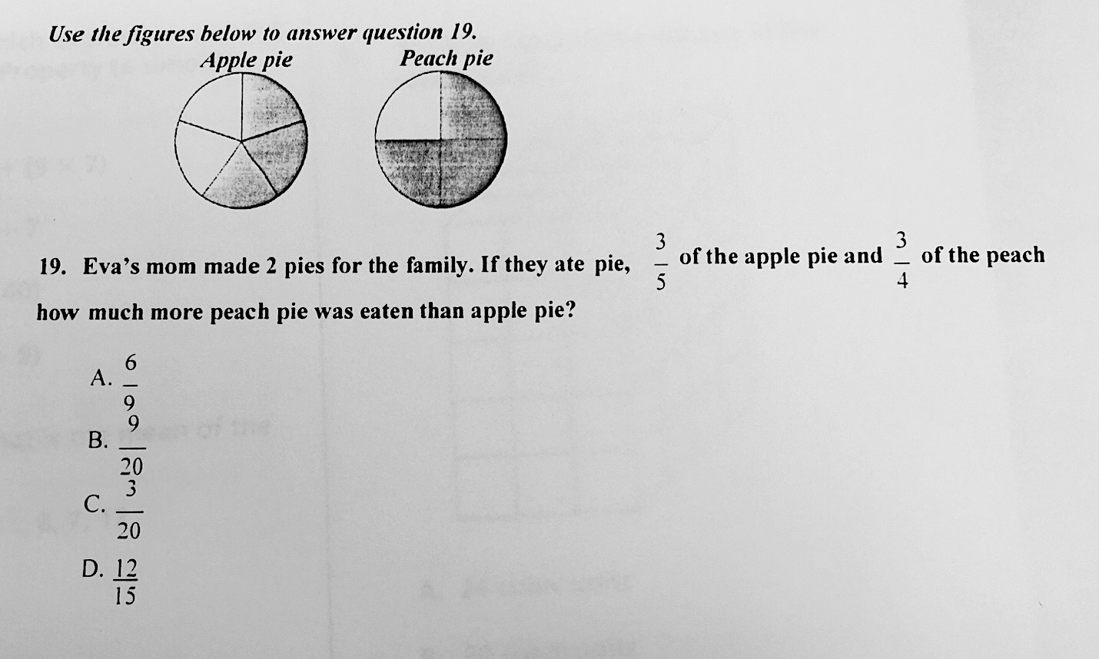

Table of Contents

Day Page

Day 1: Pre-Test/Factor Memory Game (for early finishers)………………………………………………….4

Day 2-Day 4: Adding Fractions with Unlike Denominators (Concrete)………………………………….8

Day 5-Day 7: Subtracting Fractions with Unlike Denominators (Concrete)………………………….11

Day 8-Day 9: Adding/Subtracting Fraction Card Game………………………………………………………..14

Day 10-Day 11: Factor Game……………………………………………………………………………………………….18

Day 12-Day 13: Factor Tree Activity………………………………………………………………………………………20

Day 14: Utilizing Factor Trees for Fraction addition/subtraction………………………………………….22

Day 15: Post-Test/Multiplication Card Game (for early finishers)………………………………………..23

Source Page: ……………………………………………………………………………………………………………………….27

Day 1: Pre-Test/Memory Factor Game

Objective: Students will show their knowledge of fractions by completing a pre-test.

Standards:
- 5.1.2.4 Recognize and generate equivalent decimals, fractions, mixed numbers and improper fractions in various contexts.
- 5.1.3.1 Add and subtract decimals and fractions, using efficient and generalizable procedures, including standard algorithms
- 5.1.3.2 Model addition and subtraction of fractions and decimals using a variety of representation.

Launch: The teacher will share with her student’s real life examples of when students use will fractions in their life (examples would include cooking, building, sharing food like pizza or pie, and sports). This will help show students that what they will learn in this unit is applicable to their everyday life and will interest them in their learning.

Explore: Students will take the pre-test individually.

Share: There will be no share today, as students will need most of the time to complete the pre-test.

Summarize: The teacher will conclude the lesson by reiterating to students the importance of fractions in their everyday life. The teacher will also state that all skills in the pre-test will be checked at the end of the unit and used to measure students’ learning.

Extension: Students who finish the pre-test early will play the “Factor Memory Game” in pairs. Students have played this game prior to this unit. The game is played with the numbers 4-15 printed individually on cardstock. Each of these numbers has a factor pair on a corresponding card. For example, the number 15 would have 3 and 5. If a student selects the card with 15 and the card with 3 and 5, they have made a match. Before you play, lay out all the cards face down on the table or floor. Students are to only choose two cards at a time. If they do not “match” the cards are replaced. If the cards “match” students are to keep theirs in a pile.

Assessment: The pre-test will give the teacher an idea of where students are with adding/subtracting fractions with unlike denominators, as well as putting their answer into simplest form. Depending on student results, the teacher may need to shorten or lengthen sections of the unit to fit student need.

Name______________________________________________________________

Fraction Pre-Test

Directions: Answer the following fraction questions by circling the letter of the correct answer. This pre-test will be used to show what you already know about fractions!

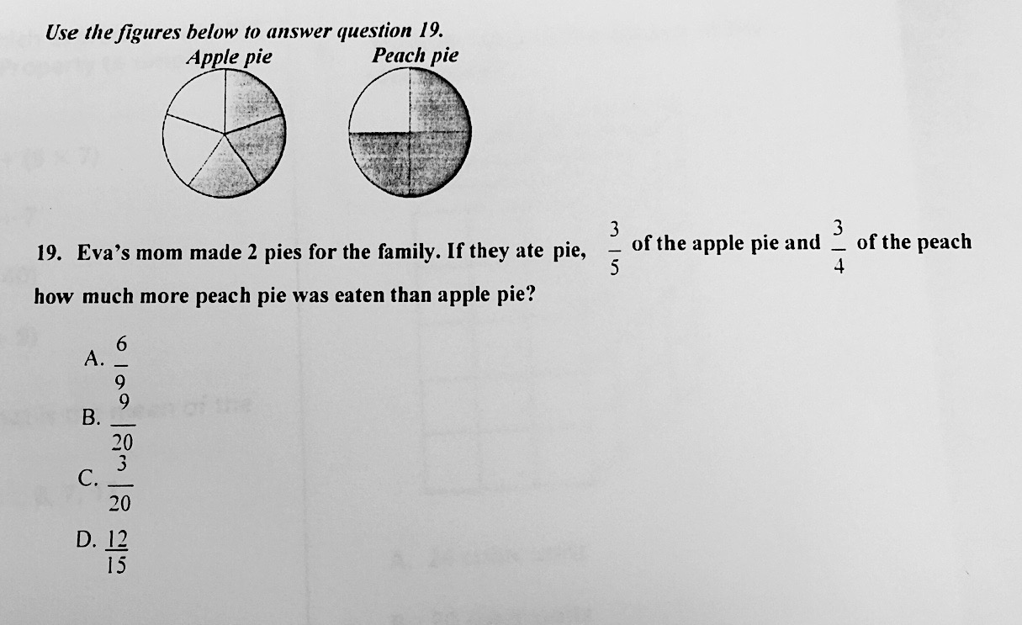

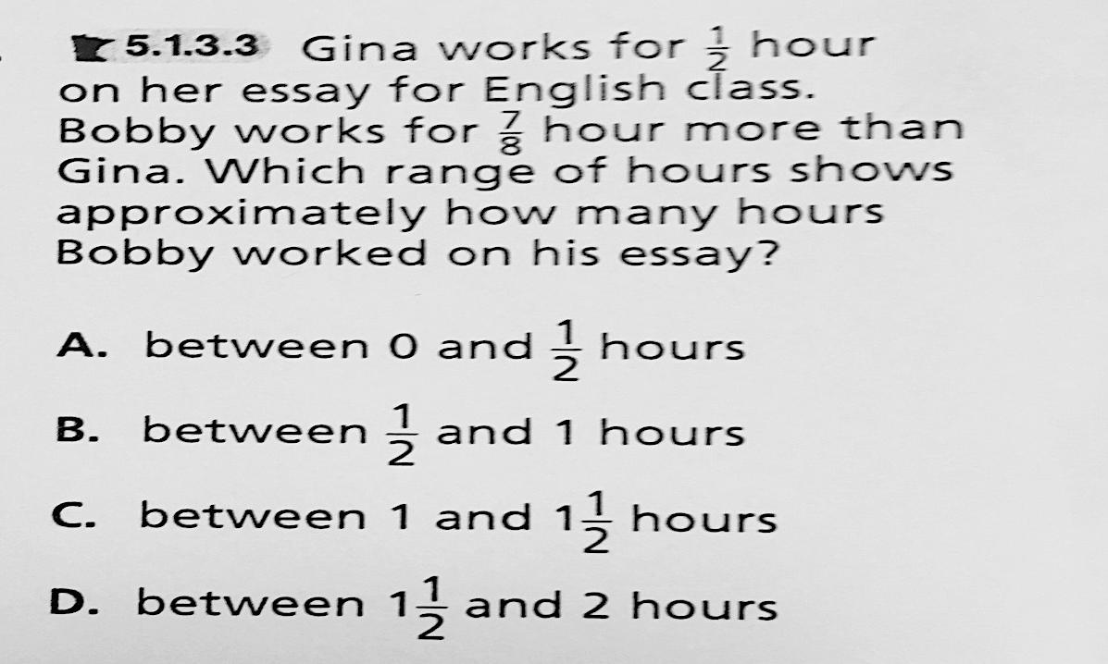

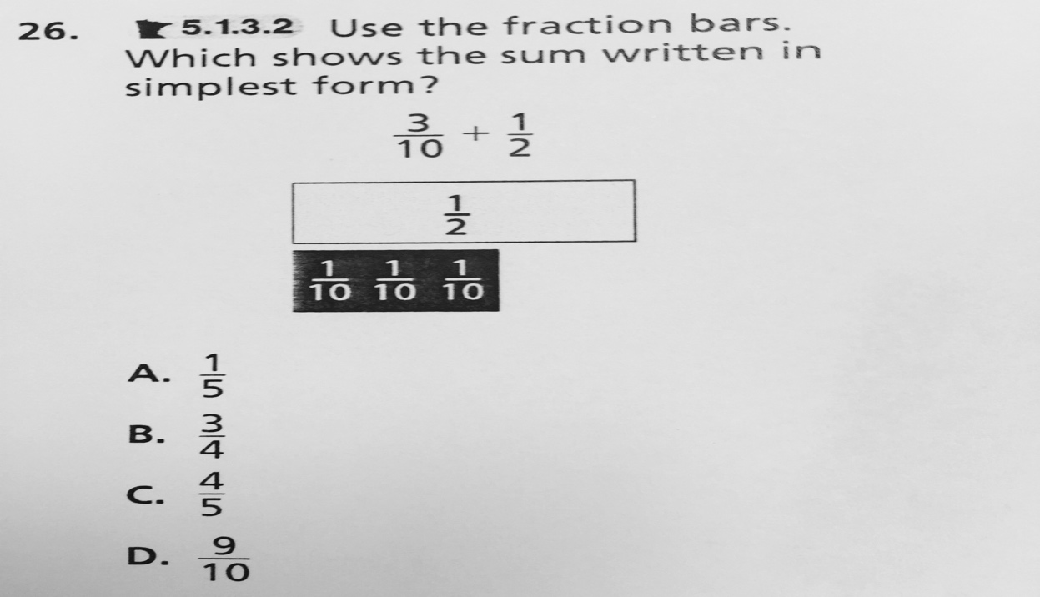

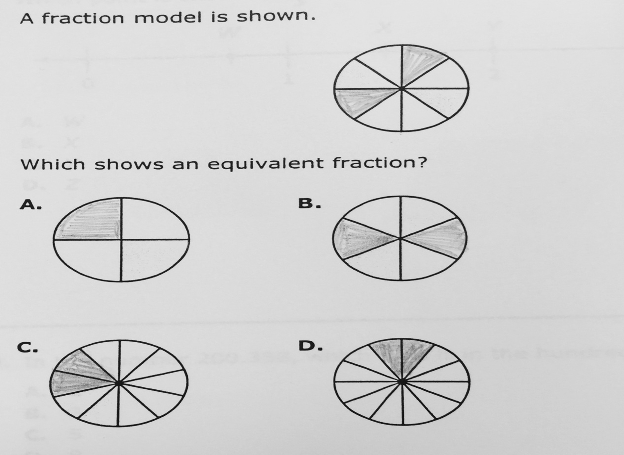

Nancy and Stephanie are competing in a race. Nancy finishes the race in 5/6 of an hour and Stephanie finishes in ¾ of an hour. How much more time did Nancy take to finish the race?

A) 19/12

B) 1/12

C) 4/5

D) 1

Day 2-4: Lesson One (Adding Fractions with Unlike Denominators)
Objective: Students will be able to add two fractions with unlike denominators.

Math Standard:
- 5.1.3.1 Add and subtract decimals and fractions, using efficient and generalizable procedures, including standard algorithms
- 5.1.3.2 Model addition and subtraction of fractions and decimals using a variety of representation.
Day 2

Launch: The teacher will bring in a Hershey bar and a Kit Kat bar. The teacher will break one piece of the kit kat bar off (1/4) and then break off 3 pieces of the Hershey bar (3/12) and give them to each student. The teacher will then ask the students “I started with two full candy bars. How much of these candy bars do you each have?”

Explore: The teacher will teach the students how to use a concrete visual to change unlike fractions into having the same denominator. The teacher will instruct the students to draw a square. This square represents one whole. Then, the teacher will have the students break up the first square into the first denominator (for example, if the first fraction is ½, the students will break up the whole square into two parts so that the parts go horizontally). Students will then shade in the number in the numerator for the first fraction (for example, if the first fraction is ½, the students will shade in 1 part because they have one of two parts). The teacher will then have the students do this with the second fraction, but break up the square into vertical parts (for example, if the second fraction is 1/4, the students will break up the square into four vertical sections and then shade one of them). The teacher will lead students in a discussion about how this visually shows the amount of each fractions. Then, the teacher will ask students how they think they can make the fractions have the same number of squares in each, so that they can be added.
**The teacher will let students work on their own with this for the rest of Day 2.
1/2 | + | 1/4 | = | ?

Day 3

Launch: The teacher will ask students to take out the problem they were working on yesterday. She will ask them, “For your fractions yesterday, can we estimate what our answer should be close to? Is ½ closest to 0, ½, or a whole? Is ¼ closer to 0, ½, or a whole? Based on that, what should our answer be?”

Explore Continued:
The teacher will have students share their thoughts. The teacher will then demonstrate an easy way it can be done. For the first fraction (1/2), the students will draw 4 vertical lines. For the second fraction, the student will draw two horizontal lines. This will break up each whole into 8 parts of the same size. It will also change the amounts shaded into 4/8 in the first fraction and 2/8 of the second fraction. The teacher will show students how to write these new fractions below the changed boxes. The students will then make an answer fraction, showing that there are a total of 6 of the 8 parts that should be shaded in. This will visually show that, after changing the denominator, the students are adding 4/8 +2/8 = 6/8 (at this point, simplest form will not be used). The teacher will have students work on two more problems.

- 1/6 + 1/3
- 4/5 + 2/3 (this will give students the chance to see that a whole box plus a fraction of a box is a mixed fraction answer).
**For each problem, the teacher will have the students use estimation (is the fraction closer to 0, ½, or a whole?) to help them check if their answer is reasonable. Students can use a fraction strip with 0, ½, and 1 marked on them to help with visualization.

4/8 | + | 2/8 | ₌ | 6/8

Day 4

Launch: The teacher will ask students to think back to how they added fractions yesterday. She will ask them, “When would be a time in your life when you would need to add fractions?” Students will share their responses.

Share:
Student will take turns explaining what they have done. The teacher will ask the students, “Is there a faster way to do this than having to draw boxes for every problem?” Hopefully, by this point students will have made the connection that they are multiplying each initial fraction by the denominator of the other initial fraction to make like denominator fractions.

Summarize: The teacher will remind students that when two fractions have unlike denominators, you must “change” them into the same so that they can be added. For concrete learners, this would be reminding students that there must be the same number of parts in both before they can be added to give an answer. If students were unable to make the connection for how to multiply each fraction by the other fraction’s denominator during the share segment, the teacher can help them make this connection during the summarization.

Assessment: Informal assessment during the explore/share portions of the lesson will provide the teacher with an idea if students are successful with the concept. Having students turn in their problems will also help the teacher assess the success of the lesson. Students will be formally assessed during the post-test. The teacher should also assess how successful the lesson was and what should be kept/changed for next year.

Day 5-7: Lesson Two (Subtracting Fractions with Unlike Denominators)

Objective: Students will be able to subtract two fractions with unlike denominators.

Math Standard:
- 5.1.3.1 Add and subtract decimals and fractions, using efficient and generalizable procedures, including standard algorithms
- 5.1.3.2 Model addition and subtraction of fractions and decimals using a variety of representation.

Day 5

Launch: The teacher will read the story The Wishing Club, by Donna Jo Napoli, to the class, to introduce subtracting unlike fractions to the class.

Book Source: Napoli, Donna Jo, and Anna Currey. The Wishing Club: A Story about Fractions. N.p.: n.p., n.d. Print.

Explore: The teacher will write the problem 3/5 – ½ = ? on the board. She will then ask the class “based on what you know about how to add fractions with unlike denominators, what is a way we can draw a picture to show how we could solve this problem?” The students will have the rest of Day 5 to work together to come up with an answer.

3/5 | - | 1/2 | = | ?

Day 6

Launch: The teacher will ask the students, “If someone gave you the choice of having 1/5 of a pizza or ½ of a pizza, which would you choose and why?”

Share:
Students will share how they solved the Day 5 subtraction problem with the teacher. Hopefully, students will have made the connection that it is the same as addition, but that instead of ultimately adding pieces for the answer, they are taking away whatever is in the second box. If students have trouble making the connection, the teacher will explain it to them. The teacher will then give students two more problems to work on (they will share their answers to them on Day 7).

- 5/6 – 2/5 =
- 3 4/9 - 1 1/3 = (this will give students the chance to see that a whole box plus a fraction of a box is a mixed fraction answer, and how to represent working with whole numbers).
**For each problem, the teacher will have the students use estimation (is the fraction closer to 0, ½, or a whole?) to help them check if their answer is reasonable. Students can use a fraction strip with 0, ½, and 1 marked on them to help with visualization.

3/5 | - | 1/2 | = | 1/10: 5 parts of the box are being taken away

Day 7

Launch: The teacher will ask the students, “How would the characters solve their problem in the story?” Students will share their answers.

Share Continued:
Students will share their solutions to the two Day 6 problems. Hopefully, by this point students will have made the connection that they are multiplying each initial fraction by the denominator of the other initial fraction to make like denominator fractions, and “regrouping” to do the subtraction if needed.

Summarize: The teacher will remind students that they use the same strategy for subtracting unlike fractions as adding unlike fractions, but that they take away the second fraction instead of adding the second fraction. If students were unable to make the connection for how to multiply each fraction by the other fraction’s denominator during the share segment, or how to “regroup,” the teacher can help them make this connection during the summarization.

Assessment: Informal assessment during the explore/share portions of the lesson will provide the teacher with an idea if students are successful with the concept. Having students turn in their problems will also help the teacher assess the success of the lesson. Students will be formally assessed during the post-test. The teacher should also assess how successful the lesson was and what should be kept/changed for next year.

Day 8-9: Lesson Three (Adding/Subtracting Fraction Card Game)
Objective: Students will be able to add or subtract two fractions with unlike denominators.

Math Standard:
- 5.1.3.1 Add and subtract decimals and fractions, using efficient and generalizable procedures, including standard algorithms
- 5.1.3.2 Model addition and subtraction of fractions and decimals using a variety of representation.

Day 8

Launch: The teacher will tell students, “Today, we are going to use what you know about adding and subtracting fractions to play a game.” She will then break students into groups of two, with each group of two playing as a team against another group of two.

Explore: The teacher will explain the rules of the game to the students (instead of using all four operations, students will choose between addition and subtraction). Each group of students will get a deck of cards, with no face cards. The aces represent one, the rest represent the value on the card. One student will pick two cards. The first card will become the numerator of the answer fraction, the second card will become the denominator of the answer fraction. Each student will then draw one card (for a total of four) and lay it face up. Each student will be able to use these four values to make any two fractions they want, and they may choose to then add or subtract the fractions. Whoever can make a problem that gives a fraction that is closest to the answer fraction gets a point (time limit 5-8 minutes a turn). Students will play best of 3 turns.

Game Source: MathFileFolderGame.com. "4 Dice: Fraction Games (Adding, Subtracting, Multiplying & Dividing Fractions)." Teachers Pay Teachers. N.p., n.d. Web. 27 June 2016.

Day 9

Launch: The teacher will ask students to think back to the game they were playing yesterday. She will ask them, “Who won? Was there a winning strategy?”

Share: Students will share their strategies for how they approached making the fractions for the game. The teacher will have students think about/share if order mattered for subtraction and if order mattered for addition. Students will also share how they could determine right away if they should try subtraction or addition first so they didn’t waste time coming up with an answer that was not close to the target answer.

Summarize: The teacher will remind students that when you add fractions, no matter what the denominator, your answer gets bigger. Likewise, when you subtract fractions, no matter what the denominator, your answer gets smaller. In order to do addition and subtraction of fractions, you have to have the same denominator.

Assessment: Informal assessment during the explore/share portions of the lesson will provide the teacher with an idea if students are successful with the concept. Students will be formally assessed during the post-test. The teacher should also assess how successful the unit was and what should be kept/changed for next year.

Day 10-11: Lesson Four (Factor Game)

Objective: Students will be able to determine factor pairs of a number.

Standard:
- 5.1.2.4 Recognize and generate equivalent decimals, fractions, mixed numbers and improper fractions in various contexts.

Day 10

Launch: The teacher will tell the students, “Today, we are going to start by playing a game. I’ll challenge all of you to a game—it will be the teacher versus all students together.” This will engage students immediately.

Explore: The teacher and students will play the factor game. The teacher will write the numbers 1-30 on the board. The teacher will tell students that the object of the game is to score the most points. For every number picked, there will be a certain amount of points the other team will get. The teacher will circle her points in red, the students’ points in black. The teacher will start by picking number 29, and giving students one point. The students will then pick a number. For whatever number the students pick, the teacher will circle the factors of that number for herself. This will continue until there are no more numbers with factors on the board. The teacher will stop the game at this point, and add up the points. She will then ask the students, “Whenever you picked a number, how was it decided what numbers I would get? Whenever I picked a number, how was it decided what numbers you would get?”
After students discuss, the teacher will share the rules of the game. One person picks a number. He gets that many points added to his total. However, for the number picked, his opponent gets the total of all the factors of the number. The person must pick a number that still has at least one factor left on the board. When there are no numbers left with a factor, the game is over and points are totaled. The students will spend the rest of Day 10 playing the factor game with a partner.

Interactive Option: The teacher can use the website “Factor Game Illumination” to have the students play the game online versus the computer, or head to head. The teacher can have students set the game board at differentiated levels (for example, one student could be using the numbers 1-12, another student could be using the numbers 1-60).

Day 11

Launch: The teacher will ask students to think back to the game they were playing yesterday. She will ask them, “Who won? Was there a winning strategy?”

Share: The teacher will ask students to think about who won yesterday’s factor game. She will have students explore if there is a best first move to make (prime number), or a worst first move to make (such as 30, because it has a lot of factors). She will have students discuss what the best strategy is. Hopefully, students will have come to the conclusion that choosing large prime numbers and numbers with very few factors are the best way to win the game.

Summarize: The teacher will remind students that every number is composed of factors. Some numbers have relatively few factors (prime), and some numbers have many factors (composite).

Assessment: The teacher will informally assess students’ knowledge of factor pairs during the factor game. Students will be formally assessed during the post-test. The teacher should also assess how successful the lesson was and what should be kept/changed for next year.

Day 12-13: Lesson Five (Factor Tree Activity)

Objective: Students will be able to write a number in prime factorization form.

- 5.1.2.4 Recognize and generate equivalent decimals, fractions, mixed numbers and improper fractions in various contexts.

Day 12

Launch: The teacher will show the “Prime Factorization Math Rap” from YouTube to the students. She will tell the students they will be using their knowledge of prime and composite numbers from yesterday to do today’s activity, which will help them factor down fractions into simplest form.

Video Source: A Plus Solutions. "Prime Factorization Math Rap." YouTube. YouTube, 2014. Web. 27 June 2016.

Explore: The teacher will write the number 18 up on the board. She will factor it down to its prime factorization starting with 2 x 9. She will then write the number 18 on the board again. She will factor it down to its prime factorization, only this time, she will start with the factors 3 x 6. She will discuss with students how, no matter what factors you start with, each number will end up with the same prime factorization. The teacher will then write the number 30 up on the board. She will have two students go to the board. Each will have to factor down 30 into its prime factorization, but will have to start with different factor pairs. The teacher will continue with more examples.

- 45
- 36
- 48

Day 13

Launch: The teacher will show the students the “Prime Factorization Math Rap” again. She will ask them, “Did this work for every number?”

Video Source: A Plus Solutions. "Prime Factorization Math Rap." YouTube. YouTube, 2014. Web. 27 June 2016.

Share: The teacher will ask the students to share if the answer changed dependent upon what factor pair students started with. Hopefully, the different examples will have helped students realize that prime factorization of a number is the same, no matter what factor pair you start with.

Summarize: The teacher will remind students that every number is composed of a unique set of prime factors. No matter how you choose to factor down the number, the prime factorization will be the same answer. The teacher will tell the students they will be using this skill to help put fractions in simplest form.

Assessment: The teacher will informally assess students’ knowledge of prime factorization as they complete factor trees. Students will be formally assessed during the post-test. The teacher should also assess how successful the lesson was and what should be kept/changed for next year.

Day 14: Lesson Six (Utilizing Factor Trees for Fraction Addition/Subtraction)

Objective: Students will be able to write a fraction in simplest form

- 5.1.2.4 Recognize and generate equivalent decimals, fractions, mixed numbers and improper fractions in various contexts.

Launch: The teacher will ask students for their help with a problem. She will lay out measuring cups on the table. She will tell them, “I was making cookies last night, and my recipe said to add 18/36 cups of flour. How do I measure that with my measuring cups?” After students discuss, she will tell them, “What if I said my recipe called for ½ cups of flour. How would I measure that with my measuring cups?” She will let students know that although there are many ways to write a fraction (equivalent fractions), the most recognizable way is in simplest form.

Explore: The teacher will write the fraction 12/20 on the board. She will ask students to help her factor down 12 to its prime factorization and factor down 20 to its prime factorization using factor trees. After writing the numbers in prime factorization form, she will have students circle all the prime numbers in 12 and 20 that are the same (2, 2). She will then have students multiply the circled numbers (2 x2 =4). This will show that the greatest common factor of 12 and 20 is 4. Therefore, 12 and 20 can be divided by 4 to show an equivalent fraction that is in simpler form. Students will then work in pairs to simplify 8/24 and 15/35.

Share: The teacher will ask the students to share how they used prime factorization to simplify 15/35. Hopefully, students will have grasped and be able to express that the amount is the same, only the answer is more “understandable” because it is in simpler form.

Summarize: The teacher will remind students that, while there are many ways to write a fraction (equivalent fractions), when you add or subtract fractions, you have to make sure your answer is in simplest form. One way to do this is through using factor trees to find out how to simply your fraction.

Assessment: The teacher will informally assess students’ knowledge of prime factorization to simplify fractions as they complete factor trees. Students will be formally assessed during the post-test. The teacher should also assess how successful the lesson was and what should be kept/changed for next year.

Day 15: Post-Test/Multiplication Card Game

Objective: Students will score 80% or above on their post-test.

Standards:
- 5.1.2.4 Recognize and generate equivalent decimals, fractions, mixed numbers and improper fractions in various contexts.
- 5.1.3.1 Add and subtract decimals and fractions, using efficient and generalizable procedures, including standard algorithms
- 5.1.3.2 Model addition and subtraction of fractions and decimals using a variety of representation.

Launch: The teacher will have the students relook at their pre-test score. The teacher will remind students that the post-test will be used to measure growth that they have made. Students will set a “growth goal” for themselves before they begin the post-test.

Explore: Students will take the post-test.

Share: The next day, the teacher will have students share how they solved each problem. Students will correct their test as each problem is discussed, and at the end, figure out their grade.

Summarize: The teacher will (hopefully) be able to tell students that they have all made good progress with adding, subtracting, and simplifying fractions.

Extension: Students who finish their post-test early will play “Multiplication Card Match” in pairs. Students have played this game prior to this unit. This game will serve as a multiplication skills refresher before students move on to multiplying and dividing fractions with like and unlike denominators. Multiplication Card Match is played by assigning values to certain cards in the deck. For instance, aces represent 1, number cards represent their value, and face cards represent 10. Students take turns taking two off the top of the deck and multiplying their values. If students are correct they keep their cards. If students are incorrect the cards are placed in the discard pile. Whoever has the most cards at the end of the game is the winner.

Assessment: The post-test will give the teacher data about how successful the unit was, and what changes should be made for the following year.

Name______________________________________________________________

Fraction Post-Test

Directions: Answer the following fraction questions by circling the letter of the correct answer. This post-test will be used to show what you have learned about fractions!

Nancy and Stephanie are competing in a race. Nancy finishes the race in 5/6 of an hour and Stephanie finishes in ¾ of an hour. How much more time did Nancy take to finish the race?

A) 19/12

B) 1/12

C) 4/5

D) 1

Source Page

A Plus Solutions. "Prime Factorization Math Rap." YouTube. YouTube, 2014. Web. 27 June
2016.

MathFileFolderGame.com. "4 Dice: Fraction Games (Adding, Subtracting, Multiplying &
Dividing Fractions)." Teachers Pay Teachers. N.p., n.d. Web. 27 June 2016.

Napoli, Donna Jo, and Anna Currey. The Wishing Club: A Story about Fractions. N.p.: n.p., n.d.
Print.

